

Attachment 6 - Schedule 11 –

Change Request Template

Mater Avanade – Managed Services

13360CON

Mater Misericordiae Ltd

Avanade Australia Pty Ltd

|  |
| --- |
| INSTRUCTIONS FOR USING THIS DOCUMENT (TO BE DELETED IN FINAL EXECUTION VERSION OF SCHEDULE):This is a template Change Request for use with the Comprehensive Contract Conditions - ICT Products and Services.Under clause 7.8 of the Comprehensive Contract Conditions, any Changes to the scope of the Deliverables or PIPP (including any change to the type of Deliverables to be supplied under the Contract, or the Requirements applying to such Deliverables) must be documented in a Change Request substantially in the form as this Schedule 11 or such other form reasonably acceptable to the Customer. If the Supplier wishes to request a Change it must submit a Change Request to the Customer.  If the Customer requests a Change it must provide to the Supplier the details of the requested Change and the Supplier must prepare and submit to the Customer a Change Request. The yellow highlighted sections need to be completed. |

QITC schedule 11 template – Issued August 2017 – Version 1.0.0

# Change Request number

Change Request #3

# Change Request dates

Date Change Request requested: 15th August 2022

Date Change Request prepared: 21st September 2022

Expiry Date of Change Request: 4th November 2022

Date Change Request intended to take effect: 4th October 2022

# Proposed implementation date of Change

This change request when executed by both parties will be effective from Date Change Request intended to take effect.

# This Schedule 8 – Change Request applies to:

Module 1 – Hardware

Module 2 – Software

Module 3 – As a Service

Module 4 – Systems Integration

Module 5 – Telecommunications Services

Module 6 – Managed Services

Module 7 – ICT Professional Services

Statement of Work Number No 1

# Summary of Change

The DevOps Pipeline will need to be improved for its ongoing Mater at Home project and merge it with Mater Foundation CRM prior to go-live on or around 23rd November 2022 (‘Project’).

Below is the current process followed for each project:

* Mater At Home

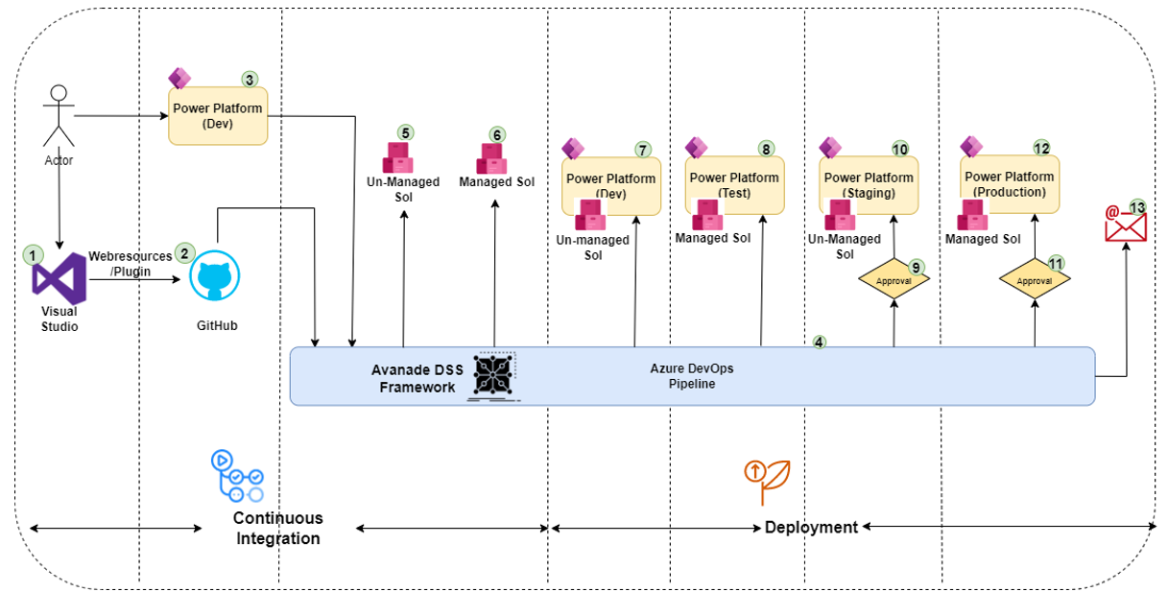

* Mater Foundation CRM

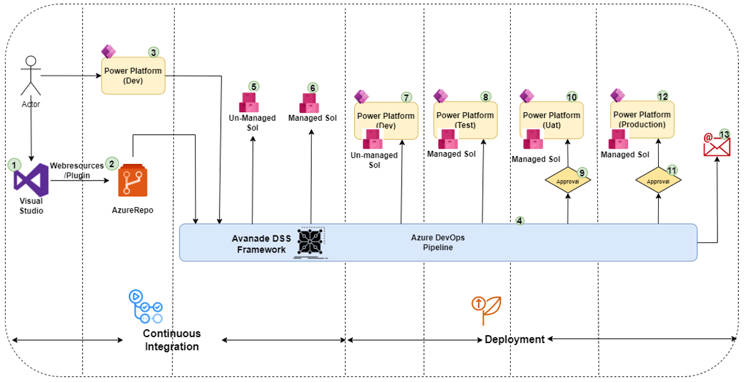

**IN-SCOPE:**

The scope of work (and proposed solution) for this Change Request is as follows:

* Migrate code repositories from Github to Azure Repos
* Consolidate all the Azure DevOps pipeline into one Azure DevOps project
* Optimize the Azure DevOps pipeline

*See section 7 – Implementation of Change for further details.

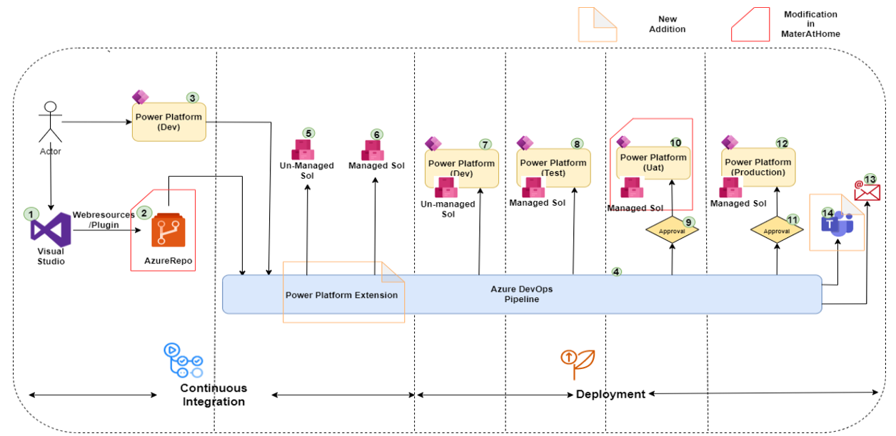

**OUT OF SCOPE:**

Any area that is not explicitly listed as within scope is out of scope for this Change Request. The parties agree that the out of scope services for this Change Request include, but are not limited to, the following:

* Mater ERP pipeline is not considered due to its dependency on the complex way of building the project, which is possible only through PowerShell scripts and only regular use credentials must be used, which poses a security risk,
* Mater Foundation CRM uses Azure Repos and UAT uses Managed solution hence only migration of code to one CRM project is required.

# Change to Requirements or Specifications

There is no change in the requirements or specifications for the current Managed Services contract.

Only the pricing for October 2022 will have to be amended to take into account the work planned on DevOps pipeline.

# Implementation of Change

**PROJECT SCHEDULE**

The implementation is divided into three (3) phases.

|  |  |  |
| --- | --- | --- |
| **Phase** | **Duration** | **Activities** |
| Analysis, POC and Design | 2 weeks | * Analysis and POC creation in POC environment * Develop low-level design document |
| Build and Test | 2 weeks | * Build pipelines * Perform unit testing on pipeline in POC environments |
| Deploy | 1 week | * Deployment of pipeline to production environment |

The proposed schedule is provided below. It includes the expected Deliverables and key milestones.

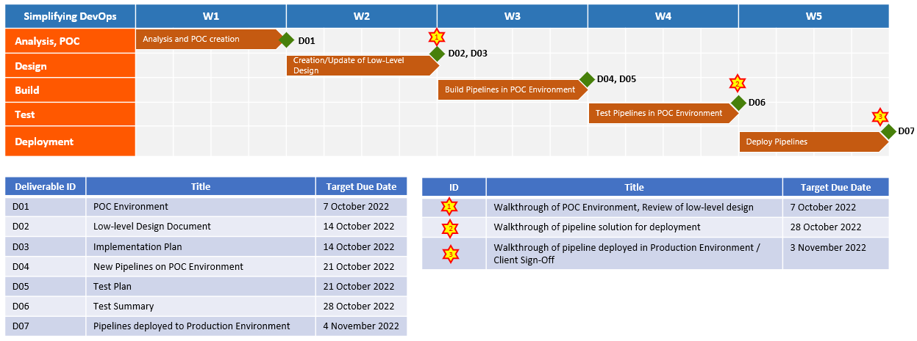

**PROJECT DEPENDENCIES, ASSUMPTIONS AND CUSTOMER RESPONSIBILITIES:**

Customer understands that the success of this Change Request is a collaborative effort, and includes certain actions which are under the control of the Customer. Set forth below is a list of the obligations for which the Customer is responsible, as well as dependencies and assumptions upon which the Supplier has relied upon in agreeing to perform the services describe din this Change Request, on the terms set out herein (collectively ‘Customer Obligations’).

If any of the Customer Obligations are not performed or prove to be incorrect or untrue, it may impact the Schedule, Fees, Deliverables, or level of effort required and result in delays to the project and increased cost to the Customer. Additionally, in the event the Supplier provides Personnel who are unable to perform services due to Customer’s failure to meet a Customer Obligation, the Supplier will bill Customer, and Customer agrees to pay, for a complete eight (8) hour day for each such Personnel.

1. **ASSUMPTIONS:**

* The Azure AD subscription accounts can be linked with Power Platform.
* The resources will be working and following local Queensland time zone business hours and holidays.
* The services are to be provided remotely wherever possible.
* The Scope, Fees and Schedule is based upon the pipelines and processes of Mater at Home and Mater Foundation CRM shared with the Supplier when this Change Request is being created. The scope and assumptions will be validated upon completion of Analysis/POC phase. If requirements change, this may result in a change to the Fees and Schedule.

1. **DEPENDENCIES:**

* The start of the project is dependent upon the completion of the following:
  + A Mater Account has been created and access to Azure DevOps has been provided.
  + Access to the GitHub Mater At Home project has been provided.
  + Access to create a pipeline in Mater Azure DevOps environment and a service principal in Azure AD has been provided.
  + POC Dev and POC Test environments are created and code is copied in the POC Dev environment for MAH20CustomizingNew.
* Mater At Home Staging (Unmanaged) has been migrated to UAT (Managed) before the commencement of Build/Deployment phase.
* Review and Acceptance of any Deliverables will be completed in five (5) days from delivery to Mater, feedback will be provided in a consolidated form.

1. **RACI:**

|  |  |
| --- | --- |
| **Description** | |
| **R** | Responsible: the person who actually completes the task, the "doer"; responsible for action/implementation; responsibility can be shared; the degree of responsibility is determined by the person with the "A." |
| **A** | Accountable: the person who is ultimately responsible; includes yes/no authority and veto power; only one "A" can be assigned to a function |
| **C** | Consulted: a person to be consulted prior to a final decision or action; has information and/or capability necessary to complete the work |
| **I** | Informed: a person who must be informed after a decision or action is taken |
| **NA** | Not Applicable |

|  |  |  |  |
| --- | --- | --- | --- |
| **Activity/Task** | **Mater** | **Avanade DevOps Resource** | **Avanade Managed Services Team / SI Team** |
| Access to Mater Azure DevOps, GitHub and Azure AD | R, A | I | C |
| Creation of POC Dev and Test Environment | A, C | I | R |
| Creation of Azure AD Service Principal | C | R, A | **I** |
| Component installation in POC Dev | C | I | R, A |
| Migration of Staging (Unmanaged) to UAT (Managed) for Mater At Home | C | I | R, A |
| POC and Low-level design document creation | C, I | R, A | C |
| Pipeline creation | C, I | R, A | C |
| Validation of Deployment | I | C | A, R |

**DELIVERABLES:**

* 1. **IDENTIFICATION OF DELIVERABLES**

|  |  |  |  |
| --- | --- | --- | --- |
| **Deliverable ID** | **Title** | **Description** | **Format** |
| D01 | POC Environment | POC Environments created for the purpose of building and deploying components in POC Dev and POC Test. |  |
| D02 | Low-level Design Document | The document will contain the names of the Azure Repos, Pipelines, Power Platform Extension and other Azure DevOps tools used in the pipeline. It will also demonstrate instructions to run pipelines and on how to choose stages to deploy. |  |
| D03 | Implementation Plan | The Implementation Plan defines the implementation approach to be taken to implement and deploy the pipelines. It consists of activities, tasks and resources required to complete the implementation. |  |
| D04 | New Pipelines on POC Environment | MAH10Webresources and MAH20CustomizingNew are stored in Azure Artifactory as managed and unmanaged solutions. This POC will also deploy the solution to the POC Dev and POC Test environments. |  |
| D05 | Test Plan | The test plan describes the scope of testing activities and defines how the elements of the solution will be tested. The test execution results are for review and assessment by Mater to inform the decision to transition to the solution. |  |
| D06 | Test Summary | The document summarizes the completed test results after performing the testing. |  |
| D07 | Pipelines deployed to Production Environment | Azure DevOps pipeline for Mater At Home and Mater Foundation CRM deployed to Production Environment. |  |

* 1. **ACCEPTANCE CRITERIA**

**Documentary Deliverables**. The acceptance criteria shall be as follows, unless otherwise agreed in writing prior to the acceptance process for such Deliverables – the Deliverable:

1. is in substantial conformance with the agreed format and scope set out in the specification for the Deliverable;
2. is clearly written, in language that appropriately skilled readers who will need to refer to the document ought reasonably be able to understand;
3. is complete, with an appropriate level of detail and any relevant cross-references; and
4. has no obvious errors of spelling, grammar, numbering or order, duplications or omissions.

**Non-Documentary Deliverables**. Unless the parties otherwise mutually agree, the acceptance criteria will be:

1. all High and Medium priority Defects are closed; and
2. there is a work-around or mitigation plan for any remaining open Low and Minor priority defects.

The applicable priority categories are as follows:

|  |  |
| --- | --- |
| **Priority Classification** | **Meaning** |
| 1 – High (Severe) | The solution cannot function at all (e.g. defects cause system crashes or data corruption) and the defect is a severe malfunction against functionality for which there is no workaround. |
| 2 – Medium (Significant) | The solution as a whole can function but the defect is a malfunction against functionality for which there is no workaround. |
| 3 – Low (Not significant) | The defect does not prevent the solution from operating, but it does not operate as it should. Business operation can continue as data availability and quality is not affected. |
| 4 – Minor (Non – Functional) | The defect has no functional impact (e.g. minor incorrect display). |

* 1. **ACCEPTANCE OF DELIVERABLES**

Review and Acceptance of any Deliverables will be completed within five (5) days of delivery to Mater, feedback will be provided in a consolidated form.

# Price

Amend Section 1 - Price - Managed Services Fee (MSF) of Schedule 1 – Price and Payment Terms to reflect a change in Monthly Price for October 2022.

The Price of this Change Request is **$42,410.77 (excl. GST and expenses)**. The billing for month of October will increase from $73,252.06 to become $115,662.83 (excl. GST and expenses).

1. **Effect of change on Delivery Dates or project implementation**

No impact to Managed Services.

**Specify whether a revised PIPP is agreed to show how the Change will be implemented**

Yes

No

# The responsibilities of the parties for implementing the Change

**Responsibilities of the Supplier**

In accordance with the amendments to Schedule 10 Statement of Work

**Responsibilities of the Customer**

In accordance with the amendments to Schedule 10 Statement of Work

# Other effects of Change

**Timing for payment**

Not Applicable

**Customer Inputs**

Managing the Program of Work for the Development POD and directing Avanade’s priorities.

**Customer assistance**

Not Applicable

**Acceptance Testing**

Not Applicable

**Performance of Deliverables**

Not Applicable

**Documentation**

Not Applicable

**Training**

Not Applicable

**LD Obligations**

Not Applicable

**Due Dates for LD Obligations**

Not applicable

# Execution of Change Request

**Execution by Supplier**

|  |  |  |  |
| --- | --- | --- | --- |
| |  |  |  | | --- | --- | --- | | Date ……………………………………..  **EXECUTED** for and on behalf of:    Name of Supplier  by its authorised representative, in the presence of:    Signature of witness    Name of witness (block letters) | )  )  )  )  )  )  )  )  )  )  )  )  ) | Signature of authorised representative  By executing this Change Request the signatory warrants that the signatory is duly authorised to execute this Change Request on behalf of the Supplier    Name of authorised representative (block letters)    Position of authorised representative | |

**Execution by Customer**

|  |  |  |
| --- | --- | --- |
| Date  **EXECUTED** for and on behalf of:    Name of Customer  by its authorised representative, in the presence of:    Signature of witness    Name of witness (block letters) | )  )  )  )  )  )  )  )  )  )  )  ) | Signature of authorised representative  By executing this Change Request the signatory warrants that the signatory is duly authorised to execute this Change Request on behalf of the Customer    Name of authorised representative (block letters)    Position of authorised representative |